|  |  |  |  |  |  |
| --- | --- | --- | --- | --- | --- |
| Date | 6-Sep-22 | | | Tester Name | Mohammad Yusuf |
| Environment | Penfax - Test | | | Login used |  |
| Operating System | Select OS | Version: | Update: | | |
| Software Used | Select Software | Version: | Update: | | |
| Select Software | Version: | Update: | | |
| Release version |  | | | | |
| Title | M17 Contributions & DCT | | | | |
| Test Type | Regression | | | | |
| Test Scenario | M17.05 Delete a file | | | | |
|  |  | | | | |
| Expected Results | File should be deleted from the dashboard/file list. | | | | |
| Pass/Fail | Pass | | | JIRA# | N/A |

Describe your steps with screenshots:

1. Log into MEPP DCT and select the Employer from the dropdown.

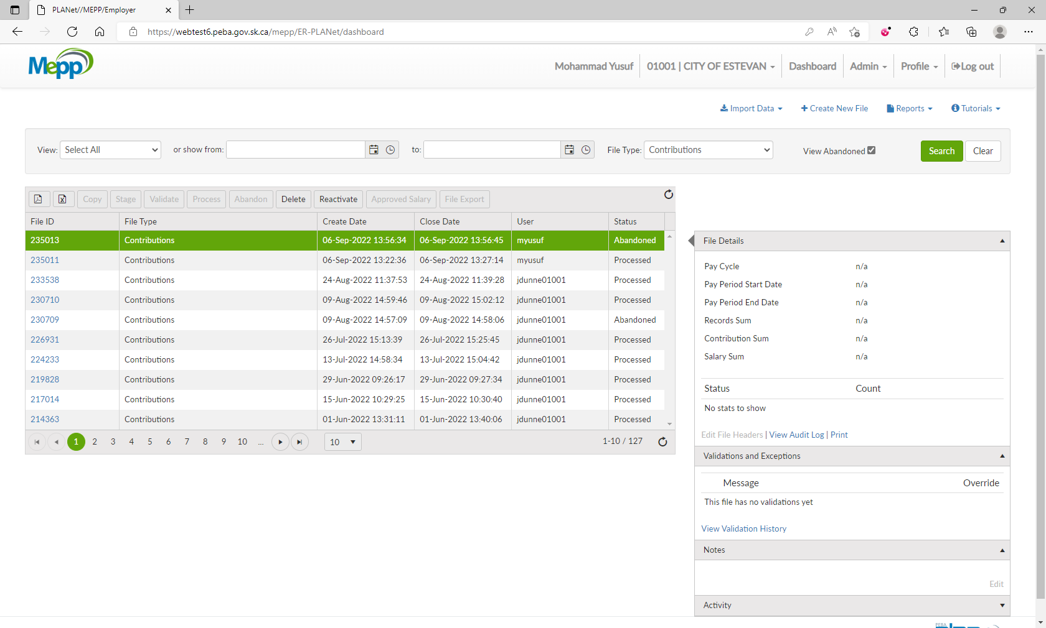

1. Click on Create New File.

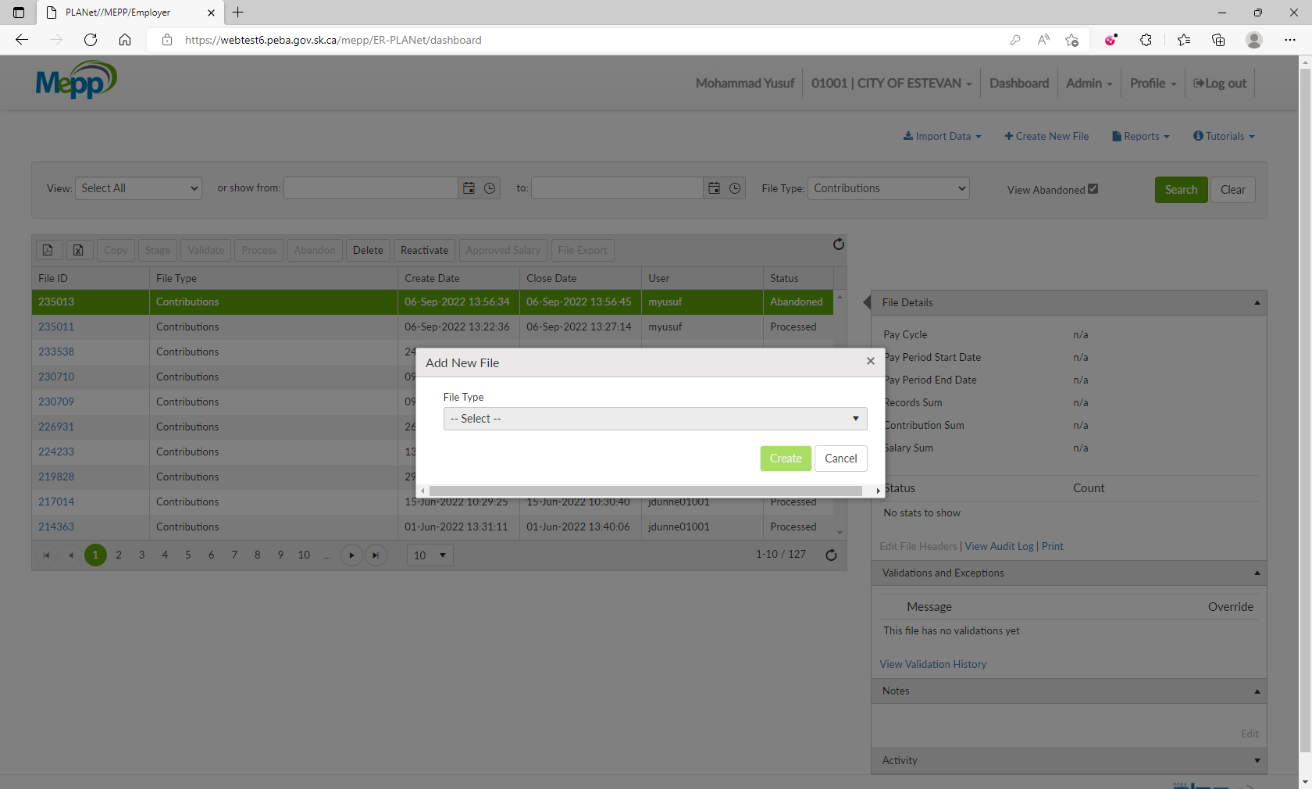

1. Select a file type from the dropdown and click on Create.

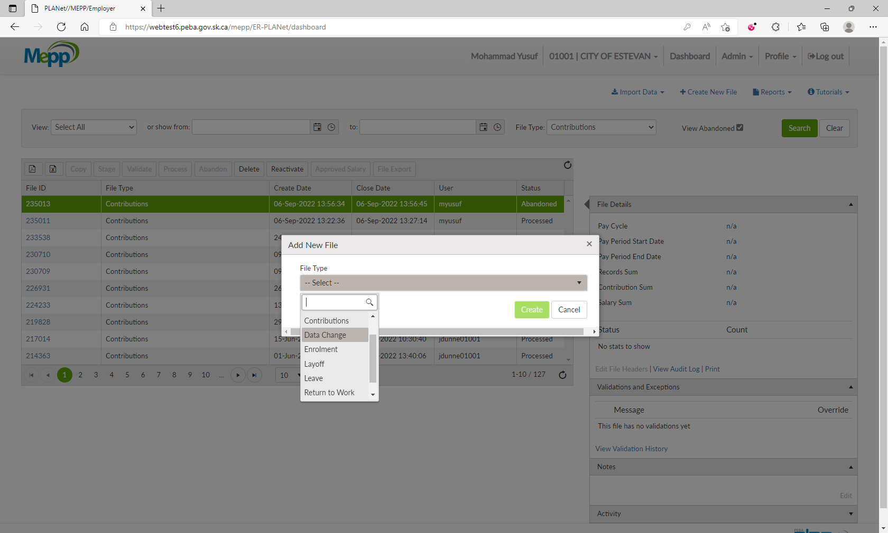

1. New file is created.

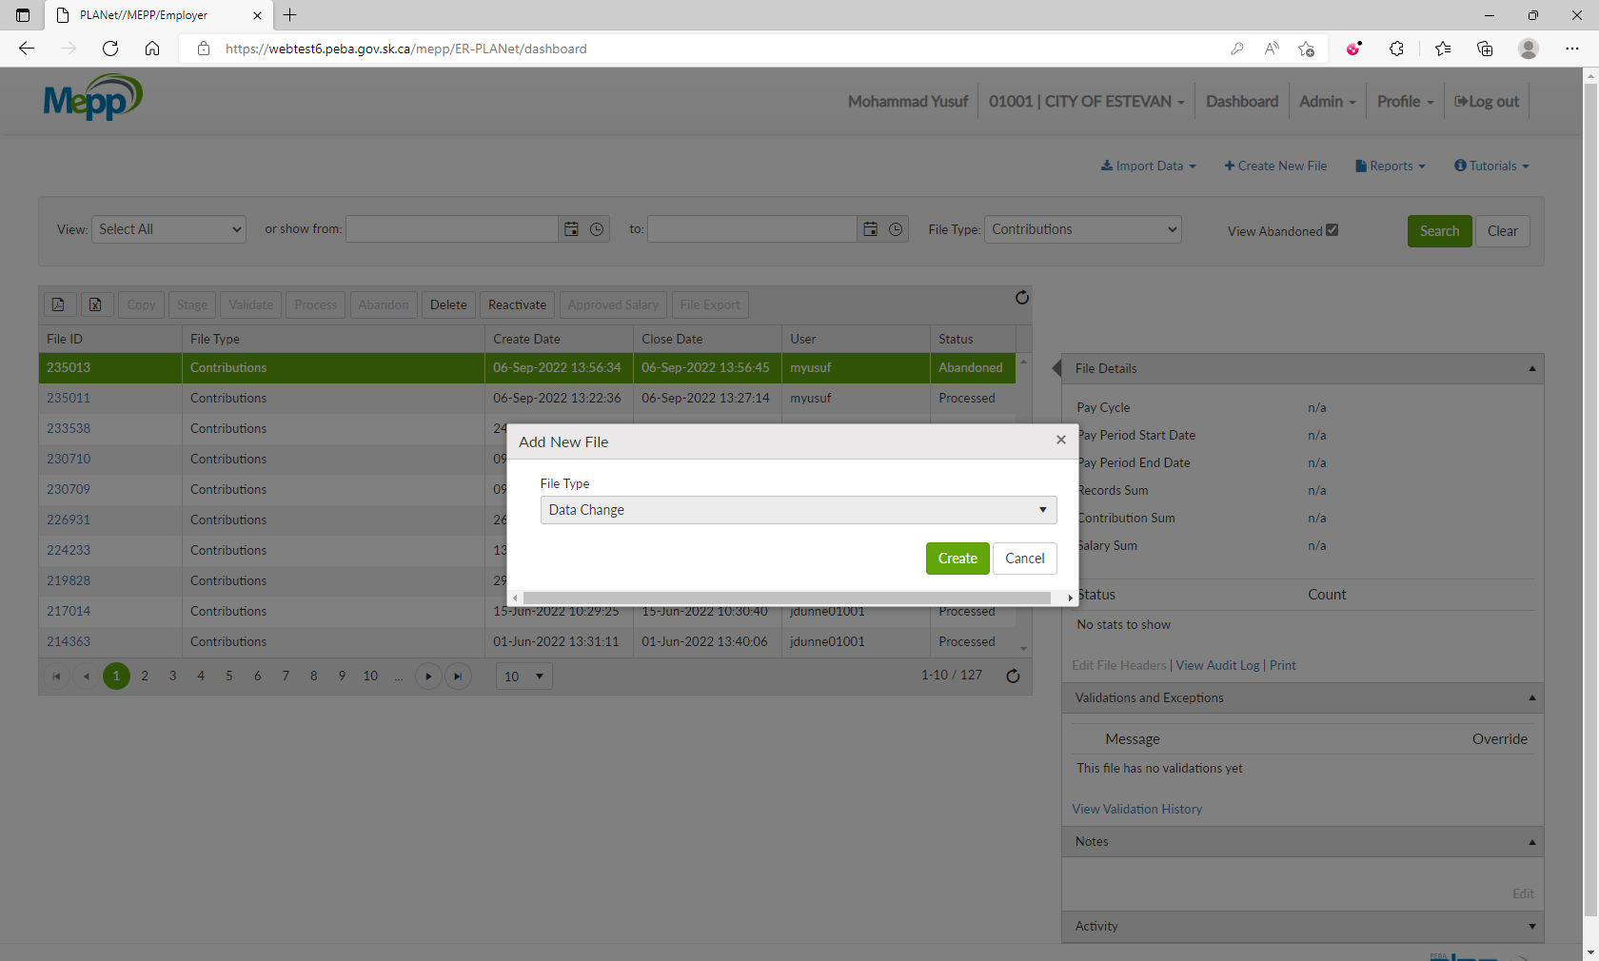

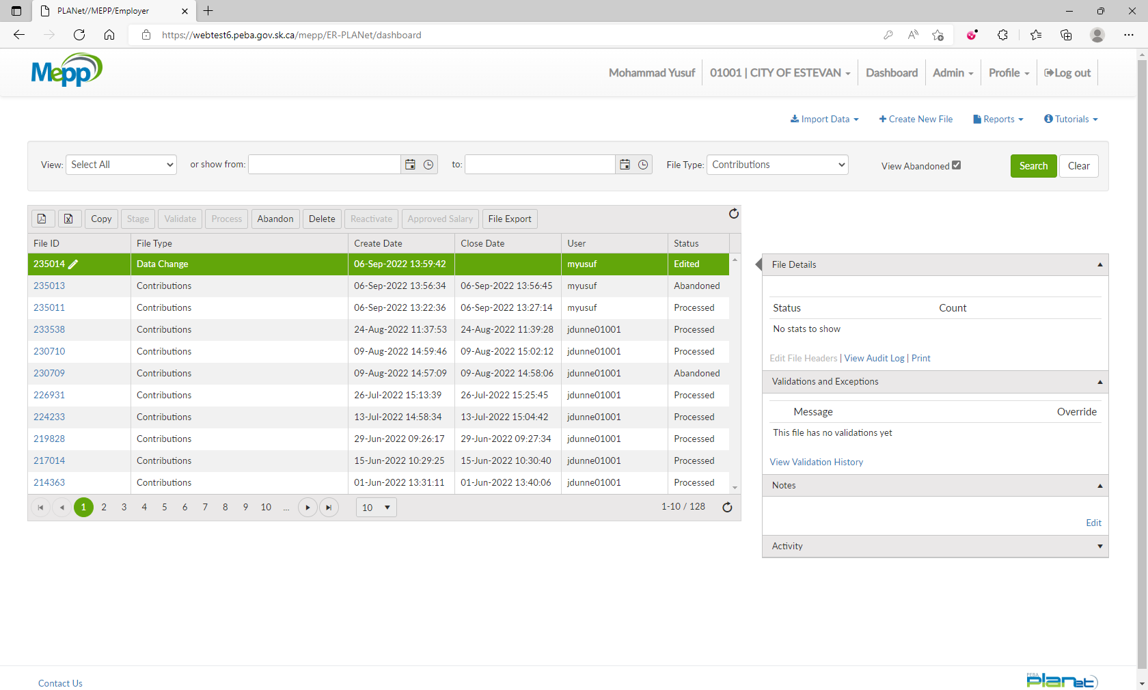

1. Click on Delete. (you can delete any of the existing files as well)

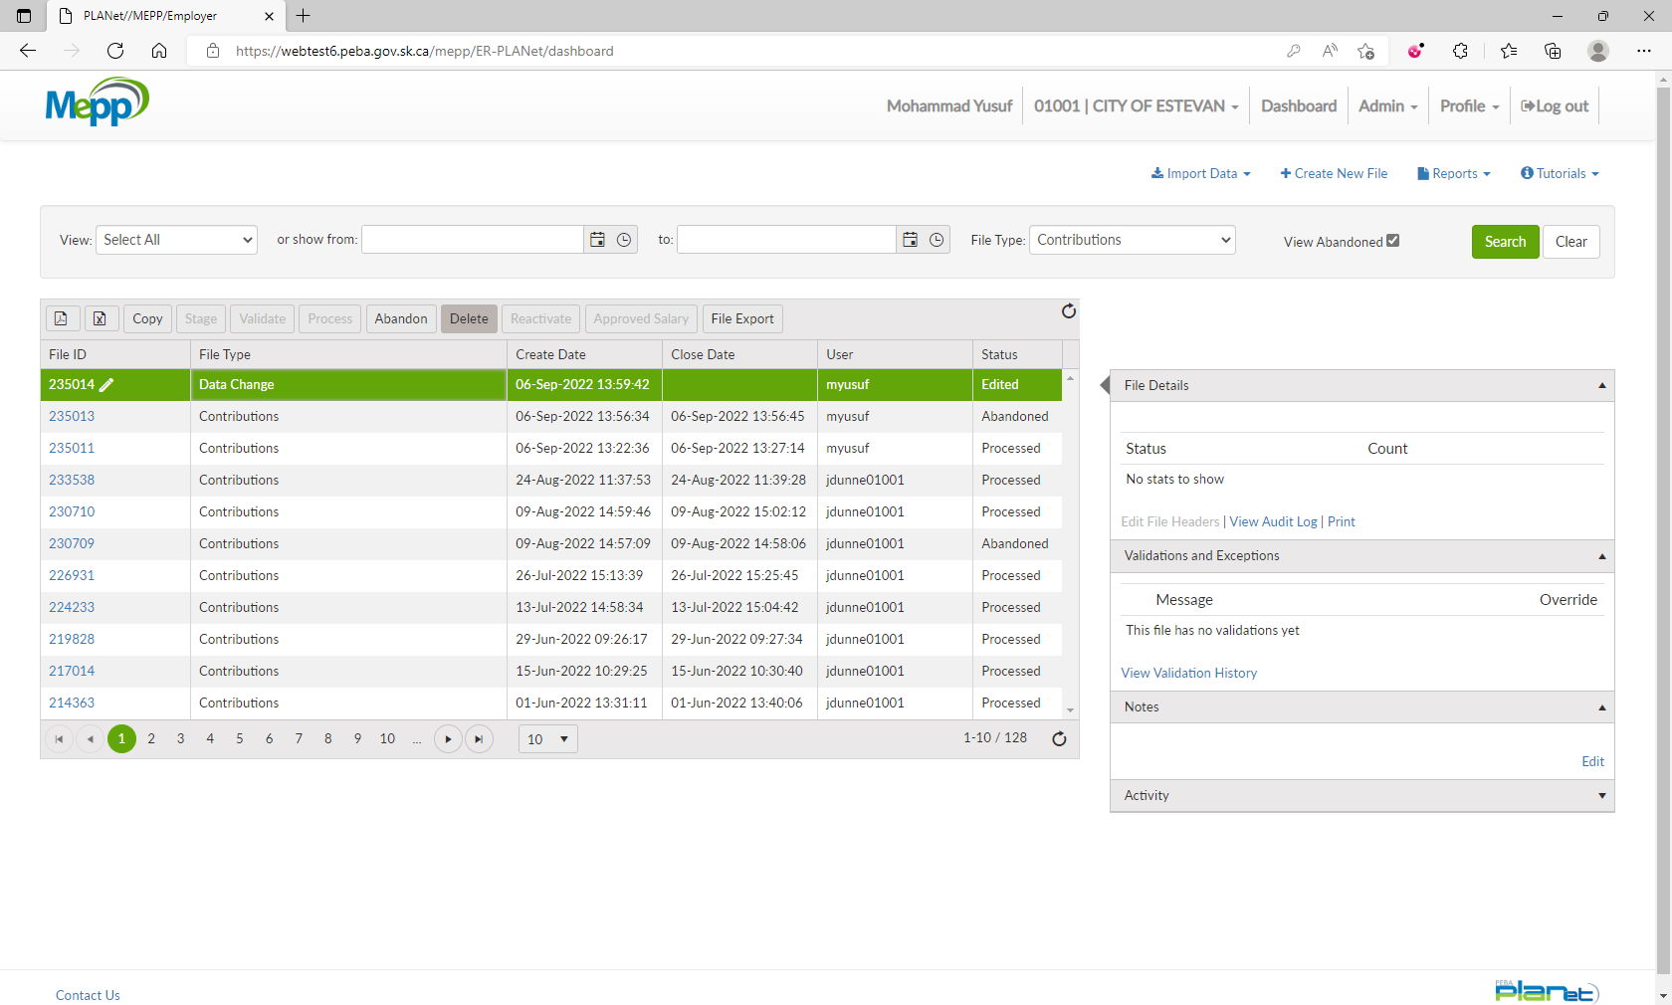

1. Click on Delete.

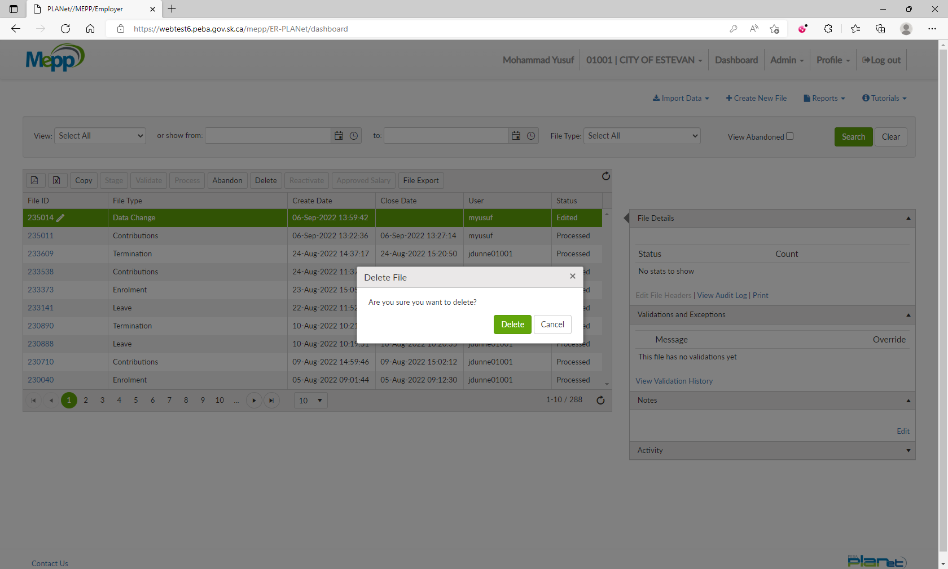

1. File is no more on the list.

